| **Ex no:12** |  |
| --- | --- |

**Aim:**

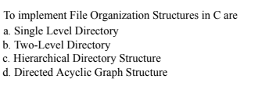

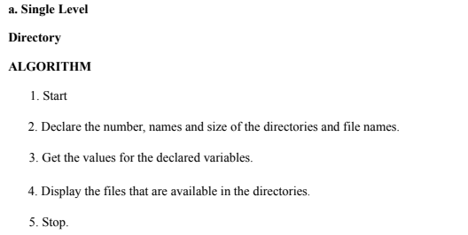

**Program:**

#include <stdio.h>  
#include <string.h>  
  
#define MAX_FILES 5  
#define MAX_USERS 3  
  
// Single-Level Directory structure  
void singleLevelDirectory() {  
    // Array of files in the root directory  
    char files[MAX_FILES][50] = {"file1.txt", "image1.png", "file2.txt", "document.pdf", "audio.mp3"};  
      
    printf("\nSingle-Level Directory:\n");  
    printf("Root Directory: \n");  
      
    // Display files in the root directory  
    for (int i = 0; i < MAX_FILES; i++) {  
        printf("- %s\n", files[i]);  
    }  
}

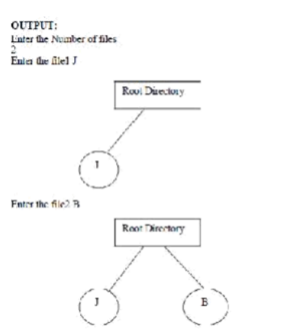

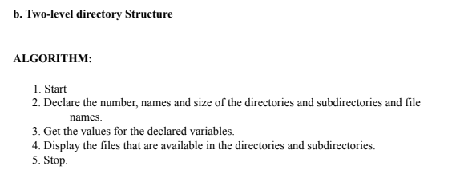

**Program:**

// Two-Level Directory structure  
void twoLevelDirectory() {  
    // Array of users and their respective files  
    char users[MAX_USERS][50] = {"user1", "user2", "user3"};  
    char userFiles[MAX_USERS][MAX_FILES][50] = {  
        {"file1.txt", "image1.png", "doc1.pdf", "notes.txt", "audio.mp3"},  
        {"file2.txt", "spreadsheet.xls", "image2.jpg", "report.docx", "presentation.pptx"},  
        {"file3.txt", "music.mp3", "picture.png", "document.pdf", "game.exe"}  
    };  
  
    printf("\nTwo-Level Directory:\n");  
    for (int i = 0; i < MAX_USERS; i++) {  
        printf("\nUser: %s\n", users[i]);  
        printf("Files:\n");  
          
        // Display files for each user  
        for (int j = 0; j < MAX_FILES; j++) {  
            printf("- %s\n", userFiles[i][j]);  
        }  
    }  
}  
  
int main() {  
    int choice;  
  
    printf("Choose Directory Organization Technique:\n");  
    printf("1. Single-Level Directory\n");  
    printf("2. Two-Level Directory\n");  
    printf("Enter your choice: ");  
    scanf("%d", &choice);  
  
    switch(choice) {  
        case 1:  
            singleLevelDirectory();  // Display Single-Level Directory  
            break;  
        case 2:  
            twoLevelDirectory();     // Display Two-Level Directory  
            break;  
        default:  
            printf("Invalid choice! Please enter 1 or 2.\n");  
            break;  
    }  
  
    return 0;  
}

**OUTPUT:**

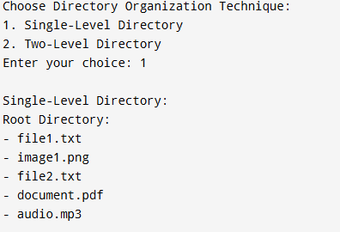

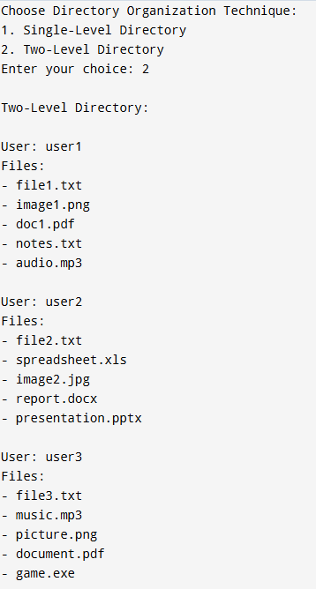

**RESULT:**

Thus the program was executed successfully.